A GUIDE TO NEONATAL VENTILATION

Sometimes referred to as IPPV, mechanical, mandatory or artificial ventilation, ‘positive pressure ventilation’ is a term that applies to the whole spectrum of modes that deliver positive pressure according to parameters set on a ventilator. This is for full respiratory support in neonates that are unable to self-ventilate adequately and where non-invasive methods as described above are not sufficient to maintain adequate respiratory function.

VENTILATOR MODES

NB: The actual terminology used may differ between makes and models of different ventilators.

Conventional modes

Continuous mandatory ventilation (CMV). This term refers to mandatory ventilation which does not allow the neonate to breathe between ventilator breaths. The recorded breath rate should be what is set. This mode is used for neonates who require maximum support and where spontaneous breathing should be minimal to avoid ‘asynchrony’ between the neonate attempting to breathe and the ventilator delivering a mechanical breath.

Synchronised intermittent mandatory ventilation (SIMV). Since mandatory ventilation delivers a predetermined number of breaths, to avoid asynchrony, SIMV ensures that the ventilator synchronises the set breaths with the neonate’s breathing. Therefore, a rate is still set but the breaths are delivered ‘in-tune’ with the neonate’s efforts by detecting these and synchronising the delivery.

Patient trigger ventilation (PTV). Patient trigger ventilation (sometimes called synchronised intermittent positive pressure ventilation (SIPPV) or assist control (A/C) ). Means that each time the neonate starts to breathe, this triggers the ventilator to deliver a breath at a set pressure and inspiratory time.
Therefore the rate is determined by the neonate. The recorded respiratory rate will be what the neonate determines unless they do not trigger atall in which case the respiratory rate will be the back-up rate that is set in the ventilator. Every time the neonate starts to breathe, this will trigger the ventilator to deliver a breath at the set pressure and inspiratory time.

Target tidal volume (TTV) or Volume guarantee (VG) A desired tidal volume (Vt) is set that is then guaranteed and delivered at the lowest possible pressure. TTV is turned on in conjunction with an existing mode and a Vt is set.

Pressure support ventilation (PS); The neonates breathing efforts are supported with a ventilator breath set to a desired pressure; similar to PTV but the neonate determines their own rate and inspiratory time (Ti). This is a mode in it’s own right or used in conjunction with others such as SIMV where the user can turn PS ‘on’ and any breath that the neonate spontaneously delivers is pressure supported to a percentage of the peak pressure set.

High frequency oscillation ventilation (HFOV). More commonly used as the mode for high frequency. Breath rates or rather ‘oscillations’ are delivered at high frequencies expressed in Hertz (60 breathes in 1 Hz). This causes the chest to ‘’bounce’’ or vibrate. The delivered pressure ‘oscillates’ around a constant distending pressure which in effect is the same as positive end-expiratory pressure (PEEP)and equivalent to Mean Airway Pressure (MAP). Thus gas is pushed into the lung during inspiration, and then pulled out during expiration. HFOV generates very low tidal volumes that are generally less than the dead space of the lung.

Nitric Oxide (NO) and Inhaled NO produces localised vasodilation in the pulmonary circulation without the systemic effects at optimal doses raging between 1-20 ppm (Dewhurst et al, 2007) and can be used in conjunction with conventional ventilators or high frequency ventilators.
TABLE 1: Ventilation Terminology – Parameters, useful formulas and definitions
(Habre, 2010; Goldsmith & Karotkin, 2011; Donn and Sinha, 2012; Petty, 2013)
Parameter | Definition | Formula if applicable & further information
Parameters that influence adequate ventilation status
Fraction of inspired oxygen (Fi02) | How much oxygen is delivered – expressed as a fraction of 1. Can also be expressed as a percentage. |  | Multiply Fi02 by 100 to calculate the percentage oxygen delivered  e.g. Fi02 of 1 = 100% oxygen  Fi02 of 0.3 = 30% oxygen
Mean Airway pressure (MAP) | The total pressure (in cm H20) within the lungs throughout the respiratory cycle as determined by PIP, PEEP, Ti and Te. Along with Fi02, this influences oxygenation |  | MAP = Rate x Ti x (PIP - PEEP) + PEEP  60 (Chang, 2011)  Pressure is displayed graphically on the ventilator’s pressure graph
Tidal Volume (Vt) | The volume of gas entering the lungs in one breath. Expressed in milliliters (mls) |  | Recommended Tidal volume (Vt) =  4-6mls / kg (reference: 19)  Vt is displayed graphically on the ventilators Vt graph
Minute volume (Vmin) | The volume of gas entering the lungs over one minute expressed as litres/ minute. Minute volume affects CO2 elimination |  | Vmin = Vt – dead space x rate (49)
Ventilator parameters (Conventional)

Rate | The number of breathe delivered in a minute – as breaths per minute (bpm) |  | Set by a dial or touch screen or set independently by adjusting Ti and Te – See Table 2. Range delivered can be 20 up to greater than 70
Peak inspiratory pressure (PIP) | The peak pressure reached at the end of inspiration (cm H20) |  | Aim to keep as low as possible, ideally less than 20 cm water (H20); if greater than 25-30 cm H20, HFOV is considered.
Positive End Expiratory pressure (PEEP) | The end pressure reached at the end of expiration (cm H20) |  | Normal range is 4-6 cm H20 although some neonates may need up to 7-8 cm H20 depending on the underlying pathophysiology
Inspiratory time (Ti) | The inspiratory time of one respiratory cycle expressed in seconds |  | This should be kept short particularly when using high rates  Range is 0.35-0.4 seconds
Expiratory time (Te) | The expiratory time of one respiratory cycle expressed in seconds |  | With a constant or pre-determined Ti, the Te will vary depending on the required rate (see above)
I:E ratio | The ratio of inspiration to expiration time |  | Te should be longer than Ti
Flow | The flow of gas delivered. Expressed as litres per minute (L/min). Ventilators will measure inspiratory and expiratory flow. |  | Flow is displayed graphically on the ventilators Flow graph
Trigger threshold | The sensitivity of the ventilator and flow sensor to detect the neonate’s breaths. |  | In most ventilators, this is a flow trigger i.e. - The threshold of flow that needs to be registered by the ventilator to detect the neonate’s spontaneous breathing.
Leak | Flow that is lost from the respiratory circuit |  | Measured as the difference between inspiratory and expiratory flow
Parameters in High Frequency Oscillation Ventilation (HFOV)
MAP | As above – controls oxygenation along with Fi02 |  | Set using the PEEP control on some ventilators that deliver both conventional and HFOV modes. Set according to pressure requirements on conventional mode (1-2 cm higher)
Frequency | Measured in Hertz (Hz) – there are 60 oscillations in 1 Hz |  | Set at a range of 8-10 Hz
Amplitude | The variation round the MAP. Also known as delta P or power and affects chest ‘wiggle’. Controls CO2 elimination |  | Set according to extent of chest wiggle / bounce and blood gas analysis
Other ventilation Terms
Oxygenation index (OI) | A calculated value to determine a neonate’s oxygen demand and associated level of oxygenation. Used as criteria for nitric and /or ECMO in the very sick newborn. |  | OI=  MAP (cm H20) X Fi02 X 100  Pa02 (mmHg)  (Chang, 2011; Mathur & Seth, 2003)
Functional residual capacity (FRC) | The volume of gas present in the lung alveoli at the end of passive expiration. |  | FRC is reduced in conditions such as respiratory distress syndrome (RDS) where there is poor lung compliance. A low FRC will affect optimum gaseous exchange.
Compliance | The elasticity or distensibility of the respiratory system including the lungs and chest wall. |  | Compliance = volume / pressure  The volume / pressure loop displayed on some ventilators represent this relationship graphically.
Resistance | The capability of the airways and endotracheal tube to oppose airflow. Expressed as the change in pressure per unit change in flow |  | Resistance = pressure / flow  Again, this is displayed graphically on some ventilators.
Pulmonary Dynamics | The real-time graphical representations of the neonate’s ventilation parameters |  | As stated above, graphs can be viewed within the Graph section of the ventilator of pressure, Vt, flow, compliance and resistance. These can also be termed waveforms, loops, mechanics and / trending displays, all of which represent the neonate’s ventilation status in real-time

NB: All measurements and graphical displays of parameters are dependent on the presence of a Flow sensor. Absence of a flow sensor will mean the ventilator will still deliver breaths but there will be no ‘measured’ readings

TABLE 2- Setting a rate using inspiration and expiration times
Confirm desired rate Divide this into 60
From this figure, subtract the inspiratory time (Ti)
This gives you the expiratory time (Te) that you need to set to get your desired rate
Example 1 - You want a rate of 60 and Ti of 0.4 seconds.
60 divided by 60 = 1 second
1 minus 0.4 = 0.6 (set the Te at 0.6 second))
This will give you a rate of 60
Example 2 – You want a rate of 40 and Ti of 0.5 second
60 divided by 40 = 1.5 seconds
1.5 minus 0.5 = 1 second (set the Te at 1 second)
This will give you a rate of 40
A NEONATAL VENTILATOR

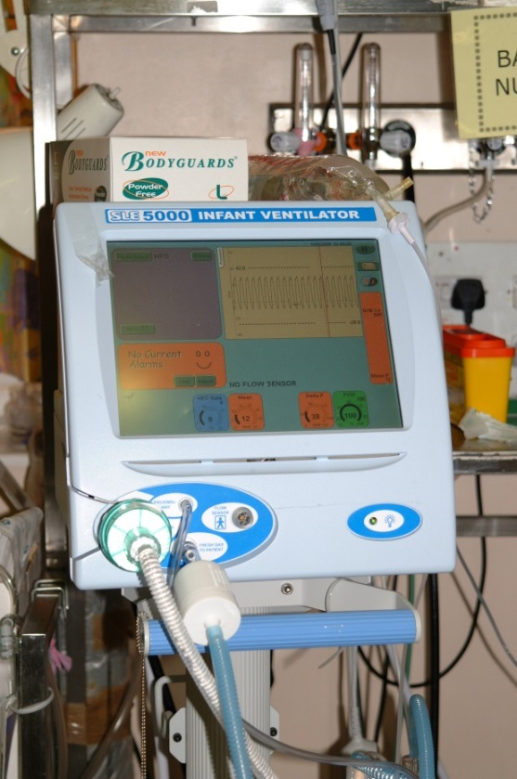

HUMIDIFICATION

Any artificial ventilation should deliver humidified gases to the airway to prevent any damage caused by dry, cold gas. A normal respiratory tract normally humidifies gases breathed in. therefore, a humidifier should be an integral part of any ventilation circuit on the inspiratory limb and should be set to deliver gases at 37 degrees Celsius, or the closest to this value, to the neonate’s airway.
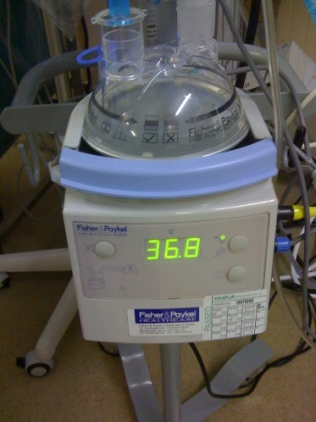
Sources: Habre, 2010; Goldsmith & Karotkin, 2011; Auckland District Health Board, 2011; Mahmoud and Schmalisch, 2011; Donn and Sinha, 2012; Petty, 2013. SLE Guidelines and User Guides

