‘Changed World’ – Hertfordshire Law Clinic
During the Covid-19 pandemic, statistics have become a part of our everyday life. Every news report gives out frightening numbers of those killed by Covid-19 and graphs and charts which are then utilised by the experts and Government officials to try and decide if they are better or worse than predicted.
One set of statistics which seem universally agreed to have worsened during the pandemic is in relation to Access to Justice. Restrictions to our movements, put in place to help with the health of the country as a whole, have had terrible repercussions for some. Lockdown, furloughing and price hikes have increased the number of people in need of urgent legal advice – and whilst the Government was swift to provide financial support for businesses, it has not offered any increase in public funded assistance with legal issues.
The variety of advice needed is wide – employment queries on furloughing and redundancy; housing concerns about tenancy rights; and desperate pleas for help from victims of domestic abuse who were trapped during lockdown in the same house as their perpetrator.
Hertfordshire Law Clinic has been giving free legal advice to members of the public since October 2019 in various areas of law including family and employment. The clinic was organised so the clients could see us for face-to-face meetings on campus or at our satellite clinic at Future Living Hertford - an award winning charity for those in recovery from addiction and domestic abuse.
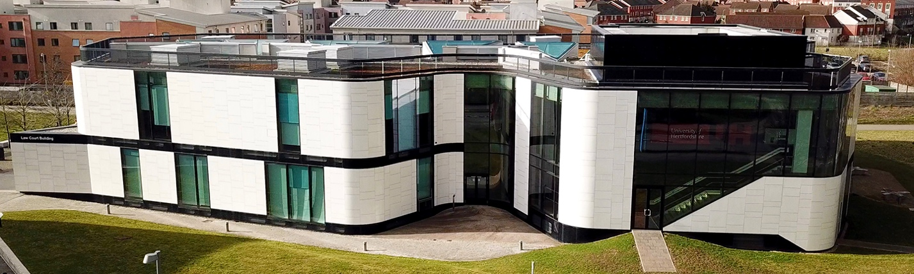
When Covid-19 forced the University to close its campus on 13 March, the Law Clinic staff did not even think about options – they knew they had to seamlessly move online to ensure continuous support for the local community at this difficult time. In a matter of days, they had set up a Zoom account and revamped guides to students and supervising lawyers. All clients were given the option of changing their face-to-face meeting to an online video meeting, or pushing it back to some unknown date after lockdown. Guess what? The vast majority opted for a virtual meeting so the zoom invites were sent out and we have never looked back.
Of course there were some technical glitches and steep learning curves for those not accustomed to speaking to a computer screen, but since the closure of campus in March the clinic has conducted 81 virtual appointments. One of the huge benefits of this brave new virtual world is that we can “see” clients even if they do not live locally in Hertfordshire.
In addition to moving to a virtual world, as a direct result of the pandemic the clinic immediately widened the areas of law it advises on in order to answer numerous cries for help from students and other tenants coming to us with urgent concerns about their housing situations. Diana Kirsch, Director of Pro Bono and Clinical Legal Education, swiftly enlisted the help and support of Ruth Camp, solicitor for housing charity Shelter, and Cheryl Gaunt, housing solicitor for Just for Kids Law, to provide advice regarding housing issues. The new housing clinic has provided advice to 15 clients. Hertfordshire Law School’s Streetlaw students also recently ran a YouTube live webinar with Ruth Camp, providing guidance to students planning to live off campus in private accommodation in September.
Hertfordshire Law Clinic was established to enable the law students at the University to gain practical experience of dealing with clients and providing advice, but it has also managed to bridge the gap where there is no longer any legal aid, or someone would simply not be able to afford the services of a solicitor. Many university and other pro bono law clinics simply shut up shop when lockdown occurred, however, Hertfordshire Law Clinic felt it owed a duty to both its student participants and the local community to carry on.
The hard work and dedication of all the students and staff involved in Hertfordshire Law Clinic was acknowledged when the clinic won ‘Best New Pro Bono Activity’ at the LawWorks and Attorney General Student Pro Bono Awards in May 2020. The Law Clinic Administrator Rebecca Howell was also awarded a Herts Hero award by the Hertfordshire High Sheriff for going the extra mile to ensure the smooth transition of the Law Clinic to the online world.
Now that the world is slowly getting back to some sort of normality, what are Hertfordshire Law Clinic’s plans for the future? In order to ensure the safety of all the supervising solicitors, students and clients, the clinic will continue to run virtually until at least the end of 2020. However, in light of the success of the virtual clinic and the flexibility it offers, it is likely that the clinic will continue to offer virtual appointments even when face-to-face appointments are able to resume.
In order to build on the success of the clinic’s first year and to further increase access to free legal advice for the local community, Amanda Thurston, Director of Hertfordshire Law Clinic, has exciting plans to launch a mobile law clinic (fondly referred to by Amanda as the ‘Justice Bus’). This initiative would see Hertfordshire Law Clinic students and their supervising solicitors provide pop up legal clinics to rural communities. A recent study showed that people experiencing domestic abuse in rural areas struggle to access legal advice and it is hoped that the new mobile clinic will go some way in addressing this problem.

