GASTROINTESTINAL (GUT) CARE OF THE NEONATE

MANAGEMENT OF NECROTISING ENTEROCOLITIS: Principles of practice

Background and Clinical features –

Necrotising enterocolitis (NEC) is a disease process involving transmural necrosis and bacterial invasion of the bowel wall. The most commonly affected site is the terminal ileum, but any part of the bowel from stomach to rectum can be affected. Onset is often acute, occasionally insidious, with non-specific features compatible with sepsis together with abdominal distension, bile stained aspirates and blood per rectum. Although prognosis is dependent on the amount of bowel affected and co-morbidities, aggressive supportive therapy is essential.

Diagnosis
- Clinical suspicion in any neonate with a picture of systemic sepsis with abdominal features.
- Non-specific radiological features (may also be seen in septic ileus). E.g. Bowel loop distension, thickening, featureless abdomen,
- Specific radiological features
- Pneumatosis intestinalis (intramural gas which can appear as a foamy appearance of the bowel wall)
- Hepatic portal venous gas
- Pneumoperitoneum (visible free gas in the peritoneum)
- Fixed dilated loop on two successive X-rays
- In established NEC, there may be evidence of systemic inflammation, with raised CRP, thrombocytopenia, abnormal WBC count, metabolic acidosis, deranged blood glucose and circulatory collapse.

Modified Bell´s Staging Criteria for Necrotizing Enterocolitis (NEC)
Adapted from http://www.medicalcriteria.com/criteria/ped_nec.htm
Stage | Systemic signs | Abdominal signs | Radiographic signs | Treatment
IA  Suspected | Temperature instability, apnoea, bradycardia, lethargy | Gastric retention, abdominal distension, emesis, heme-positive stool | Normal or intestinal dilation, mild ileus | NBM, antibiotics
IB  Suspected | Same as above | Grossly bloody stool | Same as above | Same as IA
IIA  Definite, mildly ill | Same as above | Same as above, plus absent bowel sounds with or without abdominal tenderness | Intestinal dilation, ileus, pneumatosis intestinalis | NBM, antibiotics for longer period than above
IIB  Definite, moderately ill | Same as above, plus mild metabolic acidosis and thrombocytopenia | Same as above, plus absent bowel sounds, definite tenderness, with or without abdominal cellulitis or right lower quadrant mass | Same as IIA, plus ascites | NBM, antibiotics for longer period than above
IIIA  Advanced, severely ill, intact bowel | Same as IIB, plus hypotension, bradycardia, severe apnoea, combined respiratory and metabolic acidosis, DIC, and neutropenia | Same as above, plus signs of peritonitis, marked tenderness, and abdominal distension | Same as IIA, plus ascites | NBM, antibiotics for at least 10 days, fluid resuscitation, inotropic support, ventilator therapy, paracentesis
IIIB  Advanced, severely ill, perforated bowel | Same as IIIA | Same as IIIA | Same as above, plus pneumoperitoneum | Same as IIA, plus surgery

DIC: disseminated intravascular coagulation NBM- Nil by mouth

Emergency Management
Babies with NEC can deteriorate rapidly – if you suspect this condition the baby’s management must be discussed with the duty consultant.

Airway
The vast majority of babies with NEC require intubation, ventilation and analgesia at some point – it is best to move in early with this support

Breathing
Avoid nasal CPAP. Otherwise standard ventilation to maintain normal blood gases. IN babies with marked abdominal distension or tenderness, high ventilation pressures, adequate analgesia and paralysis may be needed.

Circulation
Major circulatory disturbance is common. Preferred initial resuscitation is with normal saline. Blood, 4.5% albumin, FFP or cryoprecipitate may be needed according to results and clinical response. Maintenance fluids should only be restricted once circulatory stability is attained. Nasogastric losses should be replaced. Correction of acidosis with bicarbonate may improve circulatory status. Inotropes are frequently required; dopamine is a good first choice, dobutamine may be given second line

Feeds – stop enteral feeds
NG tube – short and largest appropriate tube (8 or 10 FG) for free drainage of nasogastric aspirates (i.e. NOT a feeding tube). This ngt must also must be aspirated regularly. This tube is for gastric decompression.
Antibiotics - Penicillin, gentamicin & metronidazole, or local antibiotics effective against likely enteric organisms (gram-negatives, clostridia and enterococci) or patient’s proven flora.

PAIN - NEC is a painful condition and analgesia up to 40 mcg/kg/hr of morphine may be required, with additional boluses for movement or handling.

OTHER- A peritoneal drain may be lifesaving with a tense pneumoperitoneum compromising ventilation.

References: Dorling et la (2005), Murdoch et al (2006), Schulzke et al (2007), Laukaityte (2013)

GASTRIC DECOMPRESSION

One of the most important, and yet simple, procedures to undergo in the surgical neonate is insertion of a short, wide-bore gastric tube for free drainage, gastric decompression and prevention of abdominal perforation. This is vital for any neonate with abdominal distension or suspected obstruction for whatever cause.

Aim; to remove as much air and gastric contents as possible’ to prevent vomiting and aspiration of stomach contents and respiratory compromise.

Method:

Pass large bore, short nasogastric tube , size 6, 8 or 10 ( depending on size of baby) or replogle tube size 8 or 10.

Length of NGT should only be 45-50 cm otherwise not effective drainage

Attach end to drainage pot and leave to free drainage (do not seal/tape the hole in lid or it would create vacuum and obstruct drainage)

Aspirate tube hourly and record volume and colour of aspirates

Aspirates are usually replaced ml for ml with 0.9 % Sodium Chloride with 10 mmol KCL added to the 500 mls bag.

REPLOGLE TUBE CARE

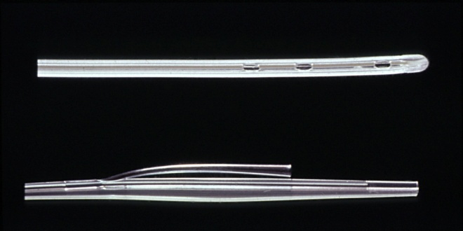

The top part of this image is the end of the replogle tube, which sits in the pouch of the oesophagus (in the case of oesophageal atresia). The lower image is the top of the tube, which, as seen, is split into 2 parts. The top smaller lumen is used to flush the oesophageal pouch– flush every 15 minutes with 0.5 mls normal saline. The bottom larger lumen is attached to low pressure suction which should continuously drain the saline and secretions out of the pouch.

