CONTINUOUS POSITIVE AIRWAY PRESSURE (CPAP)

A neonate with a respiratory condition may require support in the form of positive pressure. A non-invasive support therapy is CPAP where a constant positive pressure is applied to the airway of a spontaneously breathing neonate to maintain adequate functional residual capacity within the alveoli and prevent collapse. CPAP is administered non-invasively by a ‘Flow driver’ via two short prongs or nasal mask.

The relationship between flow and pressure means that a flow of 8-10 litres/minute should give a pressure of 4-6 (cm/water) provided that there is an adequate seal at the nostrils. Altering the flow will affect the pressure given (Petty, 2013 b). The device used to deliver the gases to the neonate’s nose is designed to support their breathing throughout the respiratory cycle in that there is a special mechanism inside the manifold above the nose that ‘flips’ when the neonate breathes in and out.

Modes on the SIPAP Flow Driver.

CPAP–Defined above. On the Flow driver, it can be given with or without ‘apnoea’. If CPAP with apnoea is required, then an abdominal transducer is necessary in order to monitor any apnoeic episode and raise the alarm according to the apnoea time interval which is set by the user.

Biphasic = 2 levels of pressure are set that alternate. There is a baseline pressure and an additional (second pressure) and when these extra bursts of pressure occur, they give extra support to the neonate. These are often called ‘sighs’

Biphasic and ‘timed’ – As above, the machine delivers 2 pressures, a set baseline pressure and an additional pressure. The baseline pressure is set using the ‘high pressure’ flow metre (set to 8 L/minute on average). If ‘timed’ the extra pressure supported ‘sighs’ are delivered according to a set ‘rate’ and inspiratory time (Ti). The user will set this additional pressure with the ‘low pressure’ flow metre seen in the image below.

Biphasic with ‘trigger’; As above but the extra pressure sighs are not timed. These are triggered by the neonate initiating a breath. Each time the neonate initiates a breath, the machine will support it with an additional burst of pressure.

BiPhasic + apnoea - as for biphasic timed but there is additional apnoea monitoring and an alarm will sound if the neonate does not breathe within the apnoea interval (as for CPAP and apnoea above).

Flow – there are 2 flow meters (See image below) on the ‘SIPAP’ model. The left one pictured is known as ‘low’ pressure where the CPAP pressure is set. The right hand one is ‘high’ pressure which is set 2 litres/minute above the low pressure dial. To re-iterate, this is what delivers the second or additional pressure when bi-phasic mode is required. It is important not to set the ‘high pressure’ flow metre too high.

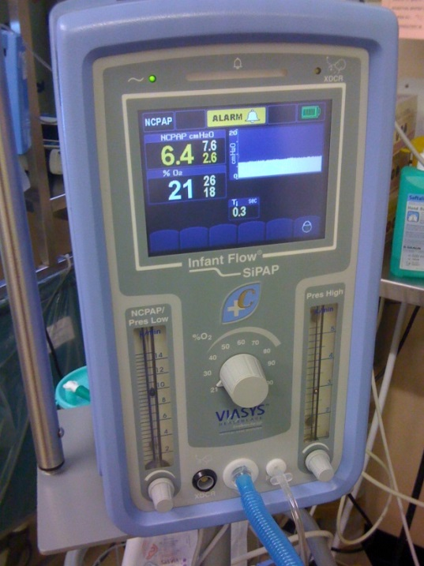

De Paoli et al (2008), Cardinal Health (2006)

