SCREENING THE NEONATE

Screening is a form of assessment that aims to identify risk for particular conditions as early as possible in order to, if necessary, refer and commence treatment as early as possible. Appropriate recommendations are made by the NHS National Screening Committee for all areas of screening including both antenatal and postnatal tests (http://newbornphysical.screening.nhs.uk)

BLOODSPOT SCREENING (taken from UK Screening Guidelines)

- All neonates admitted to Neonatal unit within 5 days of birth usually have a single blood spot taken. This is saved to send with the 5-8 day test.
- On day 5, take full blood spot test (unless a blood transfusion has been given).
- If a blood transfusion has been given in the first days of life, 72 hours is left before taking the full blood spot test.
- The full test should not be taken later than day 8
- Babies born preterm (<32 weeks gestation) require the test repeated after 28 days from birth. The UK guidelines for this recent change (2012) is as follows…
- The revised policy is based on gestational age criteria and includes babies born at less than 32 weeks gestation (less than or equal to 31+6 days) and repeat testing at 28 days postnatal age, counting day of birth as day 0, or discharge home, whichever is the sooner.

- All tests should be recorded in the medical notes.
- For neonates who have received multiple blood transfusions and no pre-transfusion blood spot was taken, testing needs to be repeated at a later date.
- Explain each test to the parents and answer questions.

** The written policy and any future updates can be found in the revised Guidelines for Newborn Blood Spot Sampling.

The newborn Bloodspot tests for ......
Phenylketonuria (PKU) is an autosomal recessive genetic disorder detected by high levels of phenylalanine in the blood. If it is not detected and treated then metabolites can accumulate and cause brain damage. Treatment is a special diet low in phenylalanine.

Congenital hypothyroidism (CH) is a condition of thyroid hormone deficiency present at birth. The cause is either a problem with thyroid gland development or of a genetic origin. Hypothyroidism can lead to developmental delay if it is not treated with thyroxin supplements.

PKU and congenital hypothyroidism are conditions, which, if untreated, can result in significant developmental delay.
Sickle cell disease including beta thalassaemia are haemoglobinopathies. The conditions affect the normal oxygen carrying capacity of red blood cells. The symptoms can include severe anaemia, intense pain, damage to major organs and infections. Although there is no routine cure for sickle cell, patients can be supported to manage their pain, and regular monitoring can help to avoid life threatening complications such as stroke.
Medium Chain Acyl Coenzyme A Dehydrogenase Deficiency (MCADD) is an autosomal recessive disorder that results from the lack of an enzyme required to metabolise fat into energy. If the child is unable to break down fats fast, the accumulated medium chain fats form toxic metabolites, which can lead to serious life threatening symptoms and even death. The treatment for MCADD is to prevent low blood sugars particularly during illness or fasting.

Cystic Fibrosis (CF) is another autosomal recessive disorder which affects the exocrine glands and the body's ability to move salt and water in and out of cells. This causes the lungs and pancreas to secrete abnormally thick mucus that can blocks the airway and prevents proper function. The accumulation of mucus can also impair the pancreas and intestine.

HIV; Surveillance can be undertaken for maternal Human Immune deficiency virus (HIV) infection based on anonymous testing of spare blood spots allowing monitoring of disease frequency in a defined population. This has been approved by ethics committees and funded by the Department of Health. This is not diagnosis in individual cases.

Source: http://newbornbloodspot.screening.nhs.uk/
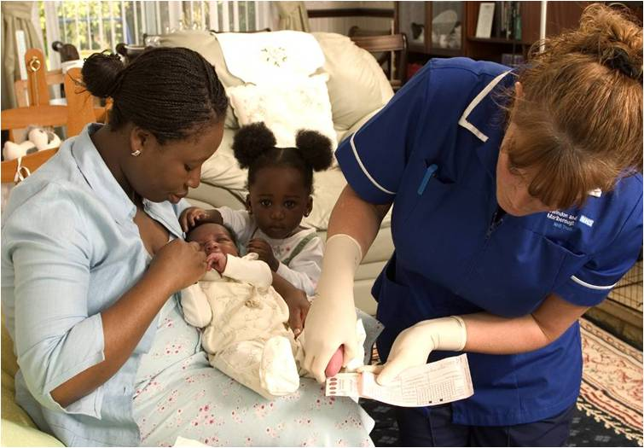
Image source: http://newbornbloodspot.screening.nhs.uk/
Used with kind permission

NB- An interactive e-learning resource is available as open access.
Go into Google and type in "blood spot card"
Then click on "interactive e-learning resource"
If you answer 15 of the 20 questions, you will be able to print out a certificate of successful completion.

SCREENING FOR RETINOPATHY OF PREMATURITY (ROP)

SOURCE- *Key Recommendations/Good Practice Points for Implementation
Royal College of Paediatrics and Child Health, Royal College of Ophthalmologists, British Association of Perinatal Medicine & BLISS UK Retinopathy of Prematurity Guideline – May 2008

Screening Criteria from the above guideline*
(NB: individual local policy needs to be observed)
- All babies less than 32 weeks gestational age (up to 31 weeks and 6 days) or less than 1501g birth weight should be screened for ROP. One criterion to be met for inclusion.
- Before 27 weeks gestational age (i.e. up to 26 weeks and 6days) - the first ROP screening examination should be undertaken at 30 to31 weeks postmenstrual age
- Between 27 and 32 weeks gestational age (i.e. up to 31 weeks and 6 days) - the first ROP screening examination should be undertaken between 4 to 5 weeks (i.e. 28-35 days) postnatal age.
- Babies >32 weeks gestational age but with birth weight <1501 grams – the first ROP screening examination should be undertaken between 4 to 5weeks (i.e. 28-35 days) postnatal age.
Minimum frequencies of screening should be weekly when: the vessels end in zone I or posterior zone II; or there is any plus or pre-plus disease or there is any stage 3 disease in any zone. All babies <32 weeks gestational age or birth weight <1501g should have their first ROP screening examination prior to discharge.

HEARING SCREENING

ALL neonates should have hearing screening prior to discharge OR arranged for community follow-up before 6 weeks (post term corrected age)
See leaflet from the NHS Newborn Hearing Screening Programme or go to (http://www.nhsp.info/). Hearing screening is carried out in all newborns as part of the UK Hearing Screening Programme. Done usually before weeks 4-6, the aim is to identify any hearing loss or difficulty that could go onto affect language acquisition in the developing infant / child. In turn, intervention is given as soon as possible to prevent a delay in this vital area of development.

The screen uses two tests called the Otoacoustic Emissions test (OAE) and the Automated Auditory Brainstem Response test (AABR). Both tests are painless.

PHYSICAL EXAMINATION OF THE NEWBORN

The UK National Screening Committee set the context for the examination of the newborn as do the NICE guidelines for Post-natal care. The Newborn and Infant Physical examination (NIPE) document focuses on pathways, standards and competencies for screening. After a baby is born an initial physical examination should be carried out. Parents are then offered a more detailed physical examination carried out, ideally, within the first 24 hours of birth, and certainly within 72 hours, to detect conditions that may need early treatment. It is repeated at the end of the postnatal period. Neonates within the neonatal unit however will be examined on a more regular basis due to them being hospitalized. They will require a full systematic assessment prior to discharge. The procedure is outlined as follows ….
Review the health history of the family, woman and baby and address any parental concerns. The physical assessment should include the following:
- appearance, including colour, breathing, behaviour
- activity and posture
- head (including fontanelles), face, nose,
- mouth including palate, ears, neck and general
- symmetry of head and facial features. Note head circumference
- eyes; check opacities and ‘red reflex’
- neck and clavicles, limbs, hands, feet and digits;
- assess proportions and symmetry
- heart; check position, rate, rhythm and sounds, murmurs and femoral pulse volume
- lungs; check effort, rate and sounds
- abdomen; check shape and palpate to identify any organomegaly
- umbilical cord
- genitalia and anus; check completeness and patency and undescended testes in males
- spine; palpate bony structures and check integrity of skin
- skin; note colour and texture as well as birthmarks or rashes
- central nervous system; check tone, behaviour, movements and posture, and elicit reflexes only if concerned
- hips; check symmetry of limbs and skin folds; perform Barlow and Ortolani’s manoeuvres
- cry; note sound
- weight; note.

Source: http://newbornphysical.screening.nhs.uk

