Developmental Care of the neonate

Developmental Care: The process of developmental care involves creating an environment for the neonate that minimises stress while providing developmentally appropriate experience for the neonate and family. Developmental care refers to interventions that
- support the behavioural organisation of the individual neonate
- enhance physiological stability
- protect sleep rhythms
- promote growth and maturation.
These interventions include…..
- optimal handling and positioning measures
- reduction of noxious environmental stimuli
- cue based care
The education and involvement of the parents or carers is critical to the neonate's social, emotional and physical wellbeing and is a crucial factor in the process of family centred developmental care.

Parental Involvement
Parents should be involved in decisions about interventions where possible. This promotes their understanding of their baby's behaviour and allows them also to practice cue based care. This allows them to experience positive interactions with their baby and empowers them to recognise behavioural cues and become more confident caring for their baby.

Neonatal unit Practices

Cue based care and clustering of cares- This involves caring for the neonate while recognising the behavioural cues or stress responses and providing an appropriate strategy such as timeout or modification of care as appropriate.

Clustering of cares encourages a minimum handling approach and protects periods of deep sleep by minimising the number of times a neonate needs to be woken up or disturbed. However, if a neonate is unable to cope with a particular cluster of care (observation of stress cues) then cluster fewer care procedures next time if possible.

Stressful / painful procedures- Minimise painful procedures and provide appropriate pain relief measures. During these procedures the use of some comforting techniques can reduce stress responses. These include non-nutritive sucking (dummy), containment of arms and or legs (swaddle or gently holding hands together on chest and/or hold legs tucked up), or grasping a finger.

Noxious stimuli - Minimise the neonate's exposure to noxious stimuli such as strong fragrances, open alcohol swabs outside incubator, clinical procedures and adhere to lighting and noise guidelines.

Feeding support - Support for breast feeding or alternatives as required with the emphasis again on individualised family centred care. Follow the neonate's cues and pace the feeds, according to their capacity to organise sucking, swallowing and breathing.

Non-nutritive sucking - Offer them opportunities to suck on a dummy or other suitable object, such as a finger, her own hands or a suitable toy. Use of non-nutritive sucking during tube feeding is helpful in the transition to suck feeds.

Staffing practices - Provide continuity of caregivers whenever possible.

Handling - Handling to minimise stress and uncontrolled responses. Contain the neonate using hands or a light swaddle to keep them in a flexed and contained position. Move neonate slowly and keep them in contact with the supporting surface whenever possible. Introduce touch slowly and allow time for the neonate to respond and adjust to a change in position.

Kangaroo care- Provide opportunities for kangaroo care when possible.
Kangaroo care is early, prolonged and continuous skin to skin contact between a parent and a low birth weight neonate.

It has been shown to……
- improve state organisation
- reduce oxygen needs, improve respiratory patterns
- reduce apnoeas and bradycardias
- improve thermal regulation
- enhance parent bonding, parental sense of competence
- enhance cognitive and motor development
Positioning: Neonates should be positioned with
- symmetrical postures
- trunk flexion, shoulder and hip flexion and adduction
- shoulder protraction, hands near face
- neutral alignment of ankles and hips
- neutral alignment of head and neck whenever possible
- the use of swaddling or nesting to provide boundaries
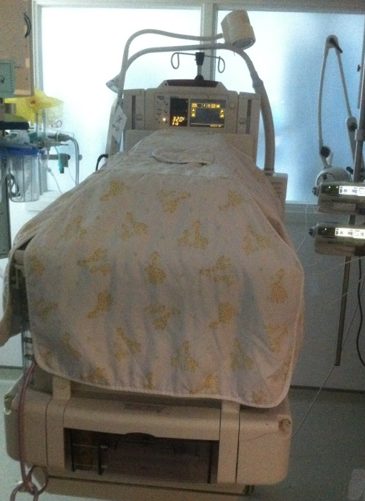

Sources; Graven (2000), Symington and Pinelli (2003), Als et al. (2004), Pinelli and Sym,ington (2005), Brindle (2006), Byers et al (2006), Rick (2006), Vandenberg (2007), Saigal and Doyle (2008)
POSITIONING THE NEONATE
Key points

Maintain flexed limbs in a mid-line position. Provide nesting / boundaries all around the baby

Side-lying
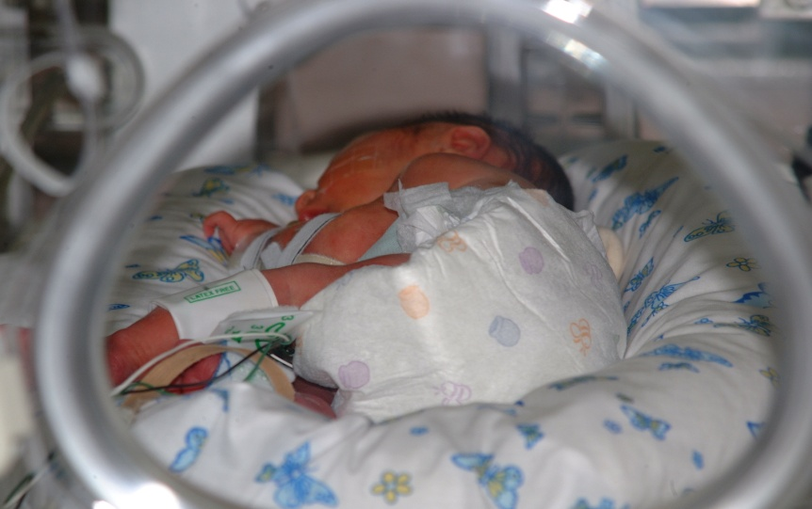

Prone
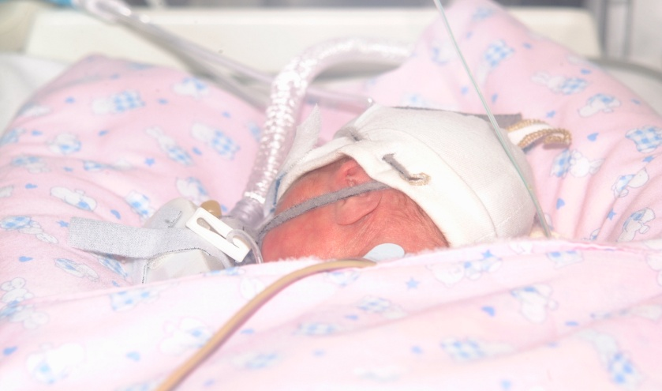

Supine
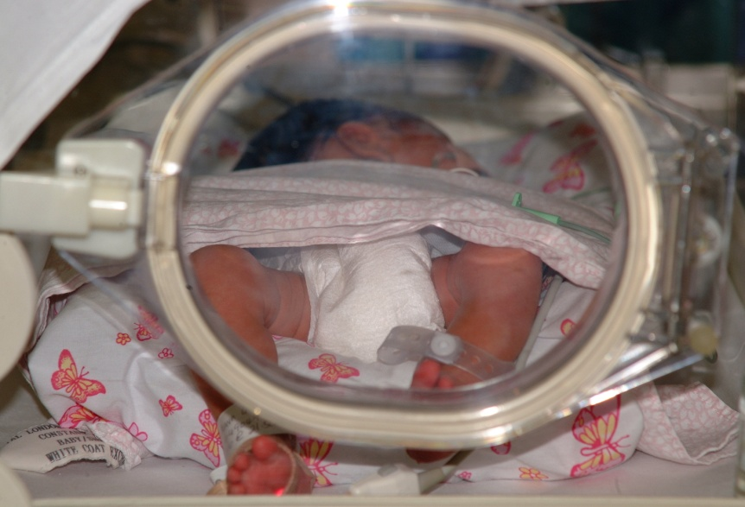

Neonatal Pain Assessment
- Neonates in hospital may experience pain as a result of diagnostic / therapeutic interventions or as a result of illness.
- Neonates display hormonal, physiological and behavioral responses when exposed to noxious stimuli.
- Assessing neonates for pain is paramount so that adequate treatment can be provided.
- Pain assessment can be considered to be a ‘vital sign’
  - Tools that aid the clinical assessment of pain are available to ensure consistency between staff/carers – some units use such tools, others do not. However, if a formal tool is not used, it is essential that pain cues are assessed (below)
PAIN CUES-
- Posture and tone – is the neonate very tense (fists clenched, trunk guarded, limbs adducted, head and shoulders resist positioning) and / or extended, trunk rigid, limbs abducted, shoulders raised from bed
- Sleep pattern – is the neonate very agitated or withdrawn, easily woken, restless, squirming, no clear sleep/wake cycles, eye aversion "shut out"
- Expression – is there a grimace, deep brow furrows, eyes tightly closed, pupils dilated or frown present, shallow brow furrows, eyes lightly closed?
- Cry – when disturbed, doesn't settle after handling, loud, whimper, whining
- Colour – Pale, dusky, palmer sweating
- Respiration – Apnoea or tachypnoea
- Heart rate – fluctuating or tachycardic
- Saturations – desaturating
- Blood pressure – hypotensive or hypertensive or normal
- Management - interventions are only a guideline and an individual approach should be used for each neonate
Analgesia – Paracetamol (non-ventilated), Codeine phosphate, morphine (if ventilated or post-operative- beware of side effects such as respiratory depression). Give regularly as required, monitor effect and potential side effects of any drug. Sedation may also be given in conjunction with analgesia – e.g. oral sedatives (Chloral hydrate) or benzodiazepines (Diazemuls, Midazolam) if ventilated.
Nursing Comfort Measures:
  - Repositioning
  - Wrapping/ containment
  - Decreasing environmental sensors
  - Tactile soothing
  - Talking to neonate
  - Nappy change
  - Dummy
  - Oral sucrose can also be used (in some units) as a method to provide non-pharmacological approach to analgesia for a neonate receiving a procedure if appropriate
  - Minimal handling
Documentation:
  - Document interventions and effectiveness of interventions on the observation chart or in the patient history
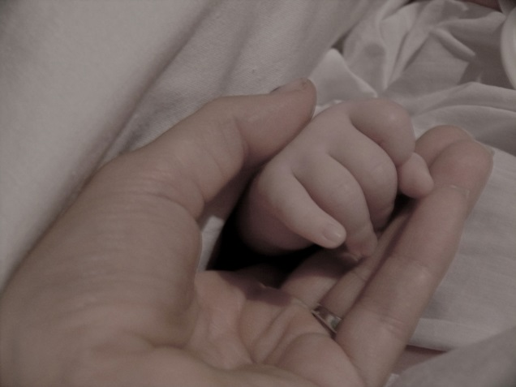
Sources; Spence et al (2005), Ranger et al (2007), RCN (2009), Cooper and Petty (2012), Meek (2012), RCH (2013)

