Chartered Educational Assessor Programme Application Form

By applying for this Programme, I agree to participate and pay the Programme fee ☐
  - Applicant Details
Name | Click here to enter text.
Current role | Click here to enter text.
Email Address | Click here to enter text.
Address | Click here to enter text.
CIEA Member | Yes ☐ No ☐

  - Programme Details
Stage 1  Certificate in Educational Assessment | Date Attending  Choose a date | £350 | ☐
Stage 2  Diploma in Educational Assessment | Date Attending  Choose a date | £750 | ☐
Stage 3  Chartered Educational Assessor Assignment | Date  To be confirmed on Applicant Approval | £350 | ☐
Stage 1, 2 and 3  Certificate, Diploma, Chartered Educational Assessor | Date Attending  Choose a date | £1195 | ☐
Please tick the Course you wish to participate in:

Please the complete this section for
The Certificate
or
The Full Chartered Educational Assessor Course (CEA)

We appreciate that in certain circumstances applicants may have sufficient knowledge, understanding and experience in assessment to warrant an exception from Stage 1 of the CEA Programme, The Certificate in Educational Assessment.

This form is available on our Website
Work Experience

Please write a brief description of your current employment situation, to include your role and responsibilities.

Please attach your current CV when sending your Application.
Click here to enter text.
Please complete this section for all Courses
Assessment Experience

Provide a reflection, no longer than 500 words, detailing your experience which you believe would make you eligible to become a Chartered Educational Assessor.
Please use the CIEA Professional framework below to support your reflection.
Click here to enter text.

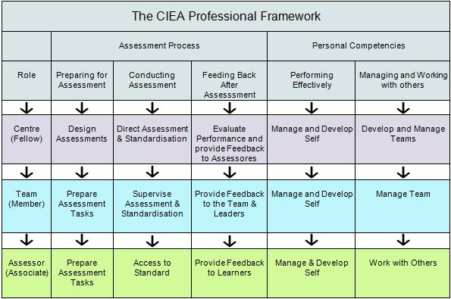

Invoice Details

Please complete details of your organisation and finance department

or your own personal details if you are self-funding your course.

Customer's full legal name | Click here to enter text.

NB: If a Limited Company please also provide official letterhead of company showing company name, number and registered office address
Customer's full postal address | FAO : Accounts Payable
Address line 1 | Click here to enter text.
Address line 2 | Click here to enter text.
Address line 3 | Click here to enter text.
City | Click here to enter text.
County | Click here to enter text.
Post Code | Click here to enter text.
Country | Click here to enter text.
Accounts Payable telephone number | Click here to enter text.
Accounts Payable e-mail address | Click here to enter text.
VAT Reg No. (EU customers only) | Click here to enter text.
UK, EU or overseas sales? | Click here to enter text.
Purchase Order Number | Click here to enter text.

Please add a Purchase Order number if your organisation requires this to be quoted on the invoice. The purchase order should be emailed to administratorciea@herts.ac.uk
If customer is  a company is it an SME? | Click here to enter text.

CHECK LIST
- Completed Personal Details for all Programmes ☐
- Completed Work Experience, for the Certificate or CEA ☐
- Attached current CV, for Certificate or CEA ☐
- Attached Exception form from Certificate, if required ☐
- Completed Assessment Experience for all Programmes ☐
- Completed Invoicing Details, for all Programmes ☐
On completion of this form please email to: administratorciea@herts.ac.uk

FOR OFFICE USE ONLY
Application Form Received | Click to enter date.
Date Approved | Click to enter a date.

