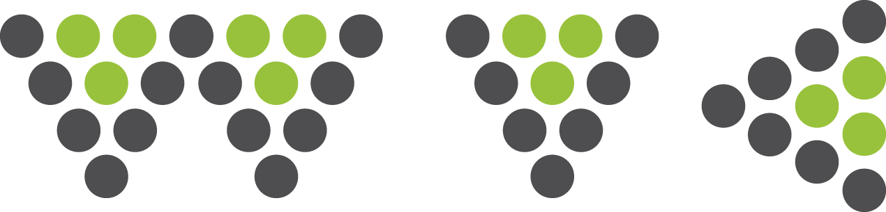

[Insert your return postal and email address here]

[Insert
Collection/Company/ Museum
Address]

Dear [insert recipient name]

1. I am requesting permission to use an image which I understand is your copyright

Image reference/description: [Insert details]

[State here if a thumbnail image is attached with the request, for reference, as is advisable]

2. This is to be included as an image in Writing Visual Culture, a double-blind peer-reviewed open access online academic journal hosted by the TVAD (Theorising Visual Art and Design) Research Group in the School of Creative Arts at the University of Hertfordshire. Details of the forthcoming academic work to which I am contributing are as follows:

Article Title: [Insert Article Title]
Journal Title: Writing Visual Culture
Volume Editor: [Insert Volume Editor]
Series Editor: Prof Grace Lees-Maffei
Date of Publication: TBC

3. The above work is intended for a limited academic readership and is to be published gratis online at http://www.herts.ac.uk/research/centres-and-groups/tvad-theorising-visual-art-and-design/writing-visual-culture. The Publishers require Worldwide English Language rights only.

Please confirm that permission is granted and, if so, if there is any permission fee to be paid. WVC is a non-commercial open access gratis publication. Our preferred form of copyright permission is CC BY-NC-ND – details are available here: https://creativecommons.org/licenses/by-nc-nd/4.0/

If you do not control World English Language Rights to this image, please notify me of any additional copyright holder we must contact.

Yours sincerely/faithfully [delete depending on whether the addressee is named above]

[Insert your name, role,
phone number as relevant
email address].

