AN INTRODUCTION TO TRIGONOMETRY

In this masterclass we will see how mathematics can be used to analyse pictures and construct a device that uses geometry to predict the location of the Sun in the sky.

You will make a lot of use of trigonometry (or simply ‘trig’). You may not have met all of the tools we will use before – don’t worry, the best way to learn something new is to use it.

Here are some useful bits of trig that will come in handy.

Pythagoras’ theorem
This relates the lengths of the three sides of a right-angled triangle:

a
b
c
θ
Sine, Cosine and Tangent

Sine (pronounced ‘sign’), Cosine and Tangent are called trig functions. Very simply they are just the different ratios you can form from the sides of the right-angled triangle. How do we find their values?

- Choose an angle in the triangle (e.g. the one labelled θ in the triangle above).
- Label the sides of the triangle: the longest side we’ll call ‘c’. The side opposite the angle we’ll call ‘a’. The other side, we’ll call ‘b’.
- In the above right-angled triangle, the ratios of the sides define the sine, cosine and tangent functions (have a look on your calculator – they’re abbreviated to ‘sin’, ‘cos’ and ‘tan’).

We can also rearrange these into useful combinations.

If we have the lengths of the sides of the right-angled triangle but don’t know the angle we can use the inverse trig functions labelled ‘arcsin’ or ‘sin⁻¹’ on your calculator (there are similar functions for inverse cos and inverse tan). Make sure your calculator is in degrees mode.

Practice with trig

- In the diagram above a = 3 b = 4, what are the values of θ and c?

Answer: We’re told a and b so we can form the ratio a/b. This is called tan θ.

Since a is 3 and b is 4, then a/b = 0.75. So we need to find the angle θ which has tan θ = 0.75. To do this we use the tan⁻¹ button on your calculator (ask if you need help). You should get the answer

Now to find the long side you can either use Pythagoras’ Theorem or another trig function. Try both ways, the answers are given below:

- Now let b = 12 c = 13. Show that a = 5 and θ is 22.6º.

- In the figure below, the radius of the circle is 7cm and the distance from the centre of the circle to the point O is 25 cm. What length of string is required when pulled taut to reach from O to the tangent point P? Notice that you get a right angle at a tangent point between the tangent and the radius to that point. (hint: use Pythagoras; answer: 24 cm)

P
O

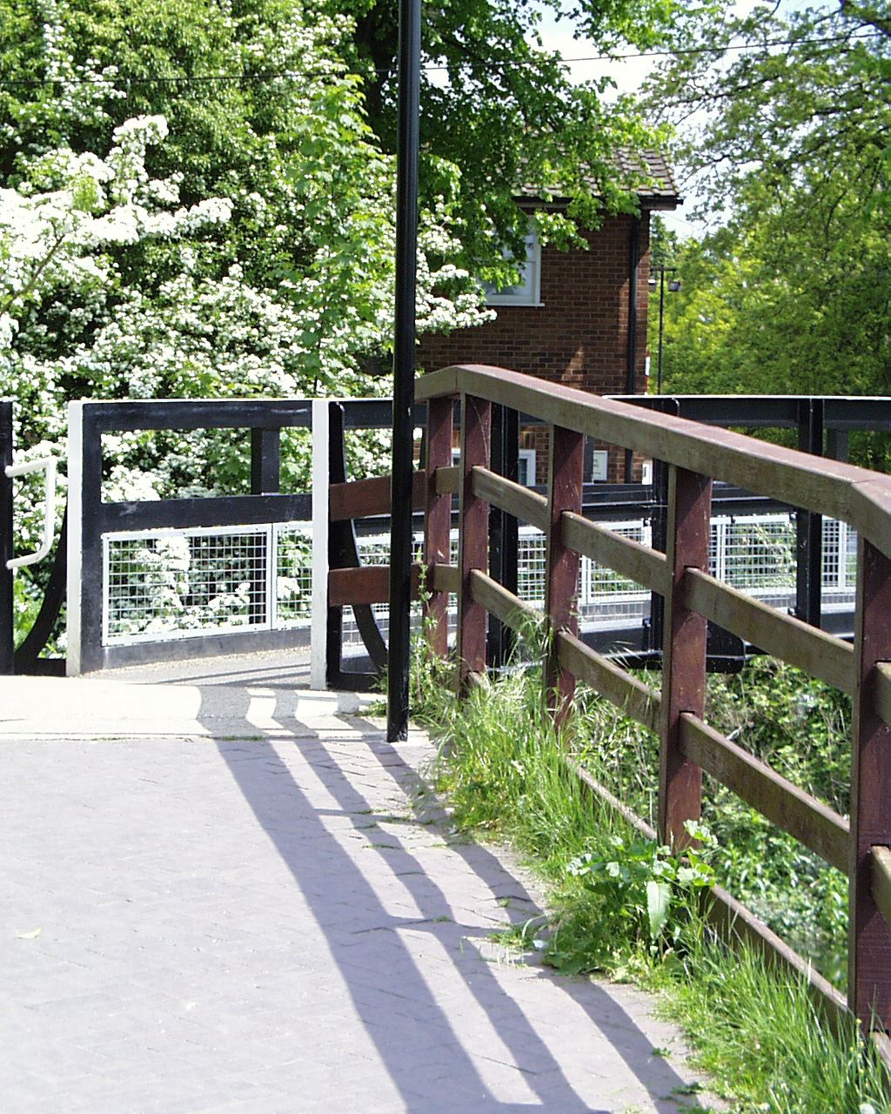 | - Take a look at the image to the left. Roughly what altitude was the Sun in the sky when the photograph was taken? (By altitude, we mean what angle did the Sun make with the horizon?) (Hint: Measure the height of a fence post and its shadow. Then use a trig function to find the angle)  - (If you have time) Take a look at the image below of the surface of the Moon taken from a spacecraft. If the diameter of the crater is 10 km and the Sun was ten degrees above the horizon on the Moon, what can you deduce about the depth of the crater?

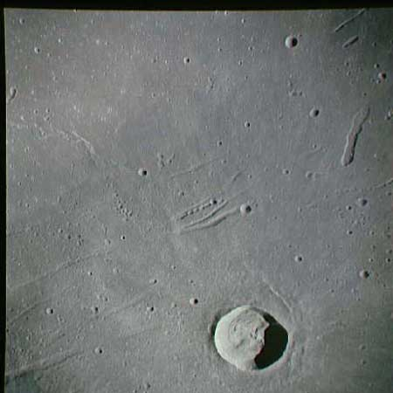 | 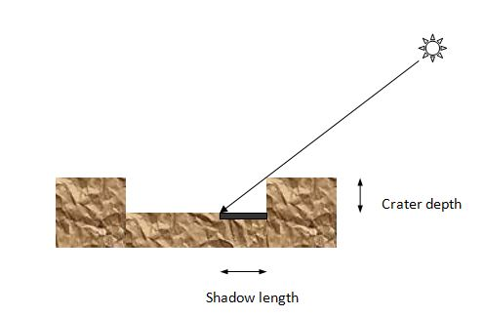

(Hint: use your ruler and make scale measurements from the photograph. If the crater is 10 km across, what is the length of the crater shadow? Given the length and the angle of the Sun, use one of the trig functions to work out the depth of the crater)

Holbein’s Ambassadors

Problem 1: The painting in the National Gallery has dimensions 207 cm x 209.5 cm. If the picture was painted ‘life-size’, how tall are the two men?

Problem 2: Take a look at the postcard. If you view the postcard at an angle, the elliptical shapes can be made circular. Focus on the largest one. To make it appear circular, tip it until the apparent length is equal to the real width. Use a trig function to find the angle ϑ between your eye-line and the elliptical shape on the card.

apparent
length
real length of elliptical shape
ϑ
To eye

Problem 3: Draw a line through the ‘long axis’ of the stretched skull on your picture of ‘The Ambassadors’. What is its gradient? Cut out a paper right-angled triangle with this slope. Move it round the picture and see if you can find positions where several interesting features lie on the same sloping line.

Problem 4: What level on the painting corresponds to the artist’s eye-level? There are several ways to do this. Not the easiest way, but an informative method, is using vanishing points (explained in the masterclass). Use the sides of the large square on the patterned floor to find a vanishing point. The vanishing point lies on the same horizontal level as the painter’s eyes.

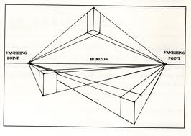

Problem 5: Can you figure out how far the painter was from the men in the picture?

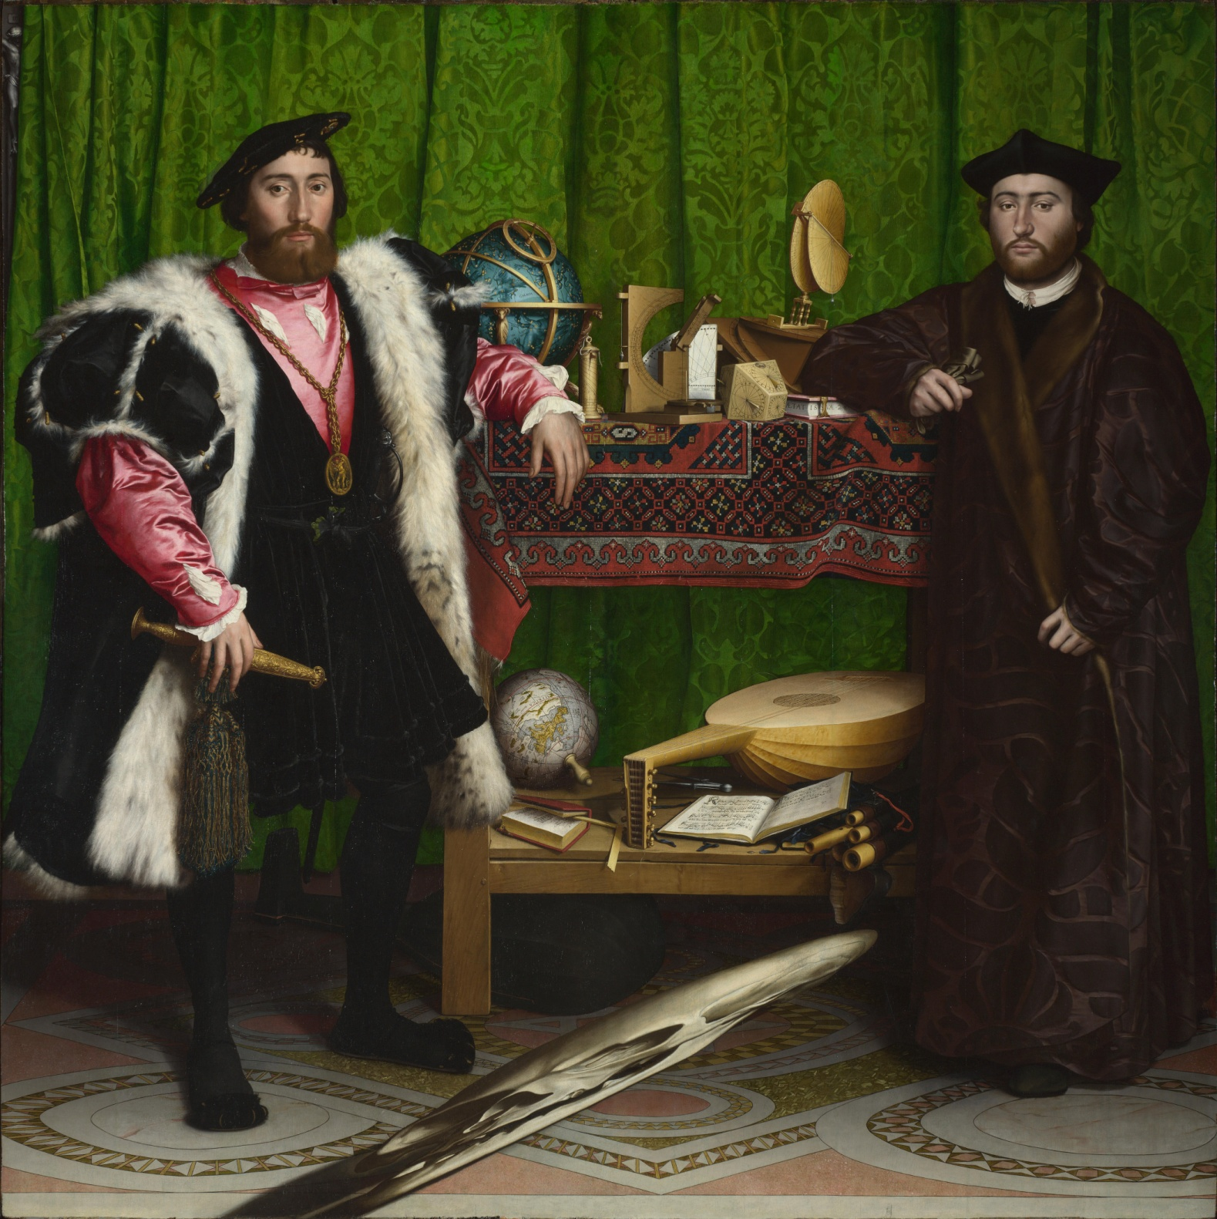
B
A
C
D
The picture below (not to scale!) is at right angles to the ambassadors and shows the eye-line from Holbein, the painter, to the two men. Make a reasonable estimate of the height of the men. Hence estimate the length AD in real life. Since the floor has a square decoration AC’ = AC. Use the fore-shortened square or perhaps the ellipses to estimate the angle ϑ. Then knowing ϑ and AD you can calculate the distance of Holbein using a trig function or by drawing a scale diagram. Note that Holbein may be on a lower floor level.

A
B
Eye-line
Floor for the ambassadors
ϑ
Ambassadors to painter distance
D
C’

