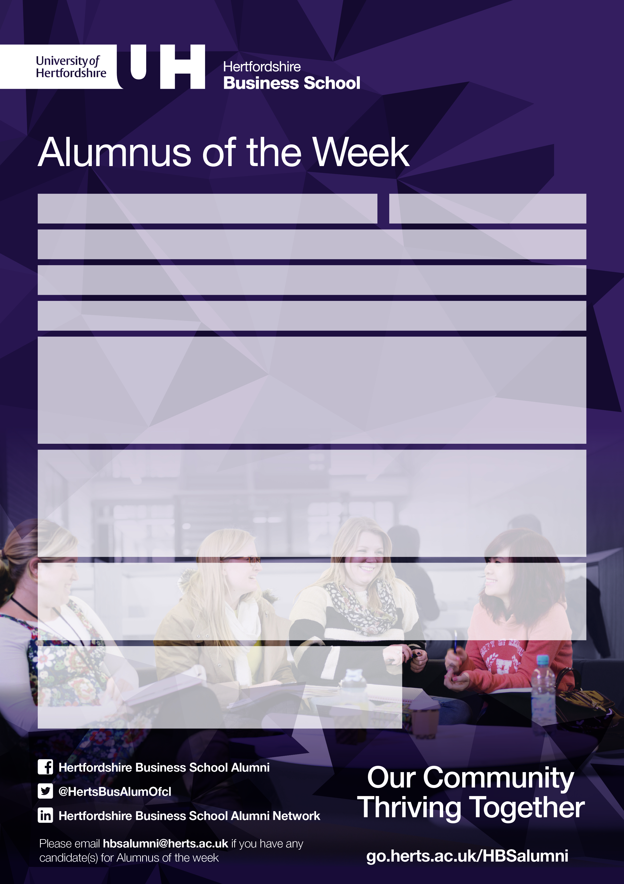 w

**Photo**

**Job Title:** Marketing & Event Coordinator

**Employer:** Nicholas & Bears

**What you liked about Hertfordshire Business School?**

Studying abroad at the Hertfordshire Business School was one of the most enriching experiences I have had thus far. The campus provided not only a very cosmopolitan and professional environment, but also an array of facilities and services that left nothing to be desired. All mentors and lecturers were very experienced and knowledgeable, which made all classes very pleasant to attend.

**Contact Details**

**Email:** [Stacie_law@ymail.com](mailto:Stacie_law@ymail.com)

**Web:** www.nicholas-bears.com

**LinkedIn:** Stacie Law

**Whom you would like to connect with in the Alumni Network?**

I would be most pleased to hear from anyone who has organised or experienced any special / innovative events in other parts of the world.

**What you do in your job?**

Working as a Marketing and Event planner at Nicholas & Bears – an international luxury kids wear brand, allows me to take part in the organisation and execution of diverse events, ranging from local fundraising campaigns, regional product launches, to a world-class Guinness record breaking event. Ensuring a lasting reputation and generating positive media coverage are always crucial for achieving a successful event.

**Programme of Study:** BA (Hons) Event Management

**Year of Completion:** 2012

**Name:** Stacie Law