Source apportionment modelling to quantify atmospheric particle emissions

S. Lawrence (1), R.S. Sokhi (1), K. Ravindra (1), H. Mao (1), H.D. Prain and I.D. Bull (2)

(1) Centre for Atmospheric and Instrumentation Research (CAIR), University of Hertfordshire, Hatfield, Hertfordshire, AL10 9AB, United Kingdom; (2) School of Public Health, Postgraduate Institute of Medical Education and Research (PGIMER), Chandigarh, 160012, India
Presenting author email: r..khaiwal@herts.ac.uk

Summary
This study aims to quantify exhaust / non-exhaust emissions and the uncertainties associated with them by combining innovative motorway tunnel sampling and source apportionment modelling. Analytical techniques ICP-AES and GC-MS were used to identify the metallic and organic composition of PM10, respectively. Good correlation was observed between Fe, Cu, Mn, Ni, Pb and Sb and change in traffic volume. The concentration of polycyclic aromatic hydrocarbons and other organics varies significantly at the entrance and exit site of tunnel, with fluoranthene, pyrene, benzo[a]pyrene, chrysene and benzothiazole having the highest incremented concentrations. The application of Principal Component Analysis and Multiple Linear Regression Analysis helped to identify the emission sources. This study shows that major health related chemical species of PM10 originate from non-exhaust sources, further signifying the need for legislations to reduce these emissions.

Introduction
The link between increased particle pollution and health issues has been well documented (e.g. Pope and Dockery, 2006), prompting the introduction of strict exhaust emission standards. However, research has shown that non-exhaust emissions also contribute significantly to atmospheric particle concentrations, highlighting the need to investigate non-exhaust emissions and their sources. Considering this, we quantified the exhaust / non-exhaust emissions by combining motorway tunnel sampling and source apportionment receptor modelling.

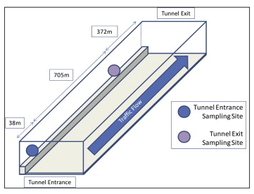
Methodology and Results
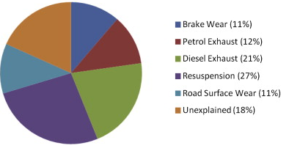
Dichotomous Stacked Filter Unit, High Volume and Partisol air samplers were employed in the Hatfield tunnel alongside traffic monitoring and meteorological equipment (see Fig.1). The PM10 and PM2.5 concentration varied between 37.6-116.8 μg/m3 and 17.3-68.4 μg/m3, respectively. Analytical techniques ICP-AES and GC-MS were used to identify the metallic and organic composition of PM10. Strong positive correlation was observed between Fe, Cu, Mn, Ni, Pb and Sb content and changes in traffic volume. The concentration of polycyclic aromatic hydrocarbons and other organics varied significantly at the entrance and exit site of tunnel. The application of Principal Components Analysis and Multiple Linear Regression Analysis helped to identify the emission sources for 82% of the total PM10 mass inside the tunnel. These sources (see Fig.2) included resuspension (27%), diesel exhaust emissions (21%), petrol exhaust emissions (12%), brake wear emissions (11%) and road surface wear (11%). The mean PM10 emission factor varies from 21.3±1.9 – 28.8±3.4 mg/vkm and was composed of motorcycles, cars, LDVs, HDVs and buses. The current study has shown that the combined non-exhaust fleet PM10 emission factor (16.7-19.3 mg/vkm) was higher than the combined exhaust emission factor (11.1-12.8 mg/vkm), demonstrating the need to mitigate not only exhaust but also non-exhaust emissions, as a potentially important source of PM10.
Fig.1 Hatfield Tunnel and its sketch map

Conclusions
Fig.2 Source apportionment of PM10 using combined dataset
As traffic volume continues to increase in the United Kingdom, non-exhaust emissions will contribute significantly to atmospheric particles. Furthermore, these emissions include several substances to toxic humans and the environment (e.g. metals and PAHs). Hence, there is need to introduce suitable legislation to regulate non-exhaust emissions.

Acknowledgement
This work was supported by NERC (NER/S/A/2004/13004) and the BOC Foundation. We acknowledge Lakhumal Luahana, Emma Tomlinson and sampling assistants for their help during sampling and/or analysis.

References
Pope C.A., Dockery D.W., 2006. Health Effects of Fine Particulate Air Pollution: Lines that Connect. Journal of Air and Waste Management Association 56, 709-742.

