Making and USING THE QUADRANT DEVICE
Warning: Never look directly at the Sun, even through sunglasses. When you are finding the altitude of the Sun, use the shadow that is cast on the two fold-out wings as explained below.
Making the Quadrant device
Cut out the two dials. Make a little snip along the dashed line and fold the two wings along the dot-dashed lines on the dials – fold the wing up on the upper dial and down on the lower dial. Secure the dials together using an eyelet. Both dials should face upwards and move freely about the eyelet pivot. Secure a cord through the eyelet hole. Thread a bead onto the cord and then the weight. Secure the end of the cord to the weight. Your quadrant should look like this.

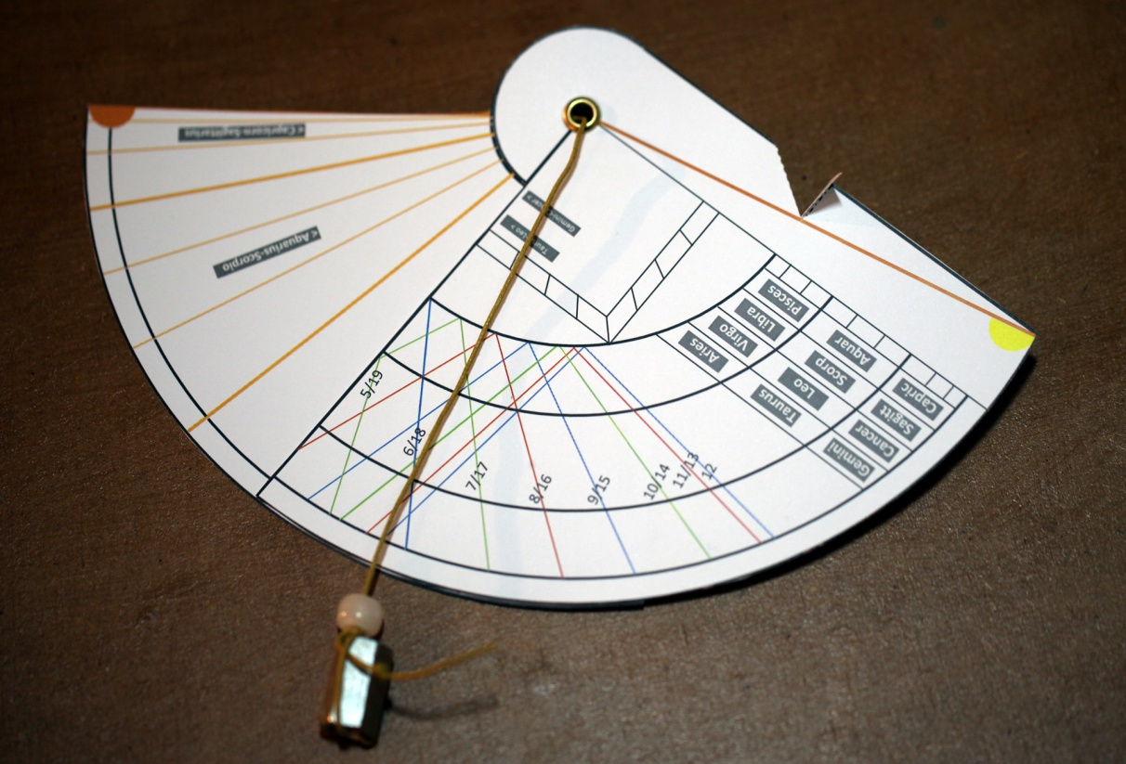
There is a space around the curved edge of the upper dial for you to add an angular scale if you wish. Mark off short radial lines in this space at 5 degree intervals. You might like to add the dates that correspond to the zodiac signs on the blank back of the quadrant. Note the quadrant has been designed for latitude 51.5 degrees north although it is still reasonably accurate for nearby latitudes.
A: Telling the time from the position of the Sun
Convert the date into a position on the zodiac scale of the quadrant. Hold the quadrant vertical. Tip the quadrant until the shadow cast on the wings is central and just touches the horizontal upper edge of the wings.
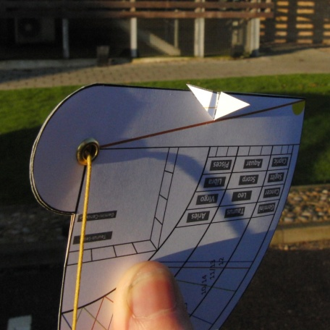 | 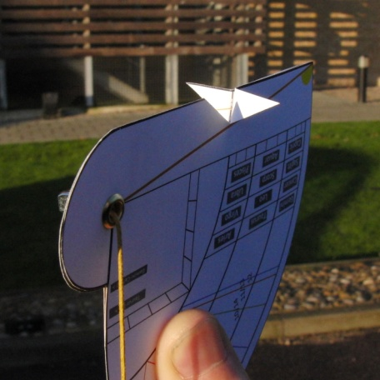 |  | 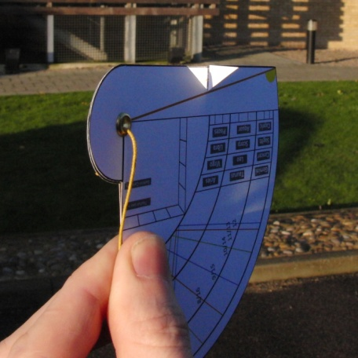
WRONG: The shadow is too far to the left and goes over the top of the wing. The quadrant needs to be tipped lower and twisted clockwise. | WRONG: The shadow is too far to the right and doesn’t reach the top of the wing. The quadrant needs to be tipped higher and twisted anticlockwise. |  | CORRECT: The shadow is central so the quadrant is pointing in the direction of the Sun and the tip of the shadow just meets the top of the wing. The quadrant is perfectly aligned and a reading can be taken once the weight hangs freely down.
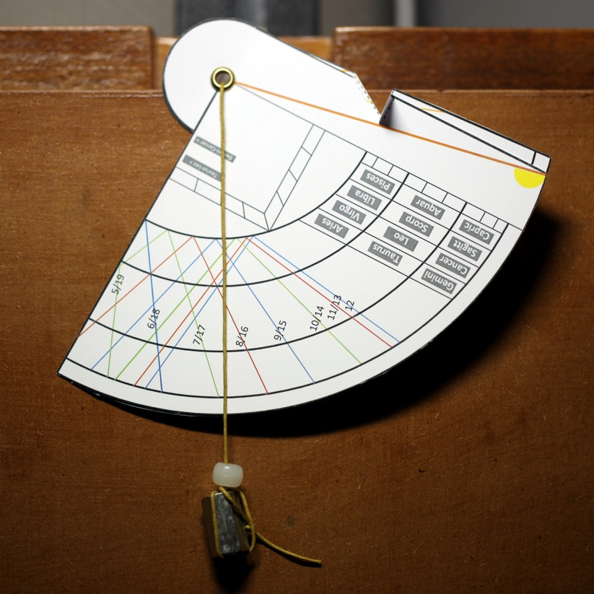 |  | 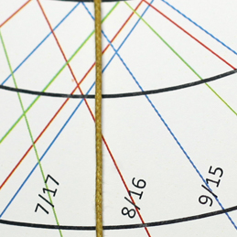
The arrow on the photo (above left) indicates the direction to the Sun.
The plumb line hangs vertically. Keep the plumb line in this position and move the bead to the point along the string matching the date on which you are using the device. Where the bead lies is the time, marked out by the numbered lines on the quadrant dial.
In the example represented by the picture above, the date is February 10th. This is two thirds of the way through Aquarius (see the arrow in the lower right picture). At this radial distance along the cord, the cord crosses the 8/16 line indicating the time is either 8 o’clock in the morning or 4 o’clock in the afternoon. We would get the same configuration on one other date: one third of the way through Scorpio - November 3rd.
B: Finding the sunset and sunrise locations
The quadrant should be held horizontally. Convert the date into a zodiac radial line on the lower dial –some major lines are indicated in orange. Bold orange lines are the boundaries of the zodiac signs. The other orange lines divide them into three parts corresponding to equal numbers of days. Rotate the lower dial until the date position just touches the edge of the quadrant dial as indicated in the photo below.
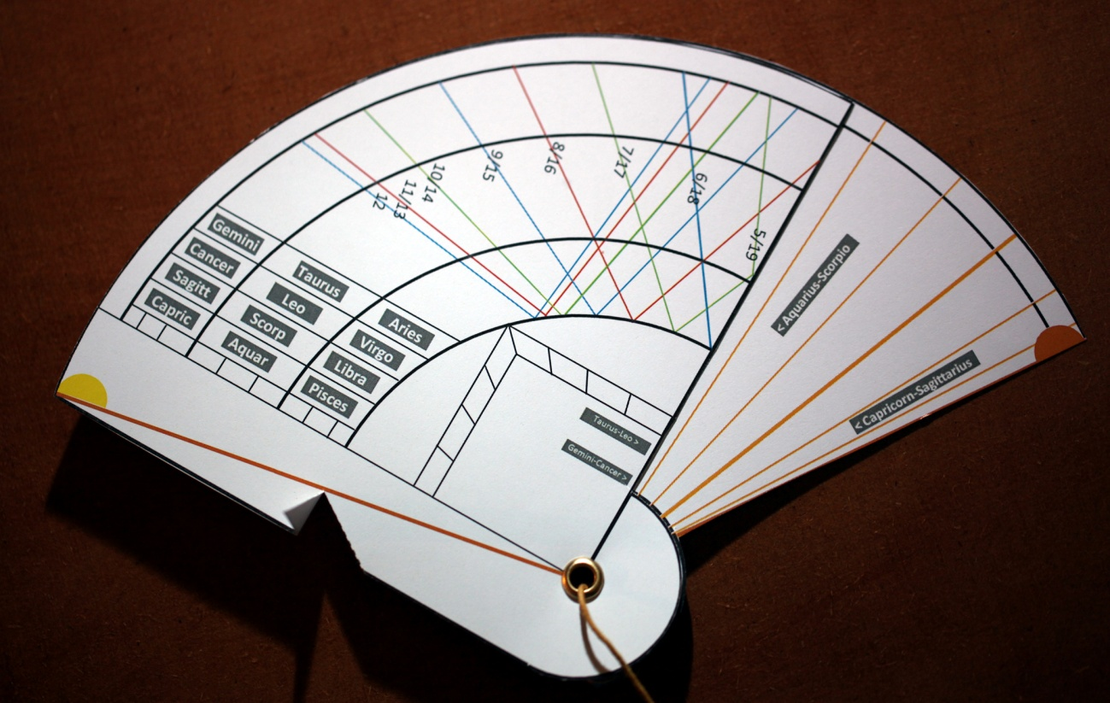

Align the yellow Sun icon with the position on the horizon where the Sun rose. The orange Sun will now indicate the point on the horizon where the Sun will set. The arrows in the figure show these directions. The device below is set up for about 5 days into Scorpio around October 29th. It is also true for one other date – about 25 days into Aquarius or around February 14th. You will notice that the positions change most quickly close to the equinoxes (when day and night are of equal length) and most slowly close to the solstices when the days are shortest and longest. Notice that due South is halfway between sunrise and sunset. The position of an object in the sky is described by two angles. These are picture below. The azimuth angle gives the bearing of the object measured eastwards from True North. The altitude gives the angle between the horizon vertically below the object and the line of sight to the object.

East
North
azimuth
altitude

C: Measuring the heights of trees
You are now finding the altitude of a tree (or any vertical structure) instead of the Sun. You can use your degree markings to work out this altitude. The tree will not cast a shadow like the Sun, so you can sight directly along the quadrant edge. Once you have the angle and the horizontal distance to the tree, you can use trigonometry to work out its height.

