Chartered Educational Assessor Programme Application Form
By applying for this Programme, I agree to participate and pay the Programme fee

Applicant Details
Name
Current role
Email Address
Address
CIEA Member | Y / N

Programme Details
Please tick the Course you wish to participate in:

Stage 1  Certificate in Educational Assessment | Date Attending  Enter Date | £350 | Y / N
Stage 2  Diploma in Educational Assessment | Date Attending  Enter Date | £750 | Y / N
Stage 3  Chartered Educational Assessor Assignment | Date  To be confirmed on  Applicant Approval | £350 | Y / N
Stage 1, 2 and 3  Certificate, Diploma, Chartered Educational Assessor | Date Attending  Enter Date | £1195 | Y / N
Charity No.1122014
Page 1 of 5

Please complete this section for The Certificate
or
The Full Chartered Educational Assessor Course (CEA)

We appreciate that in certain circumstances applicants may have sufficient knowledge, understanding and experience in assessment to warrant an exemption from Stage 1 of the CEA Programme, The Certificate in Educational Assessment. Please contact us at administratorciea@herts.ac.uk to apply for an exemption form.
Work Experience
Please write a brief description of your current employment situation, to include your role and responsibilities.
Please attach your current CV when sending your application.

Please complete this section for all Courses

Assessment Experience
Provide a reflection, no longer than 500 words, detailing your experience which you believe would make you eligible to become a Chartered Educational Assessor. Please use the CIEA Professional framework below to support your reflection.
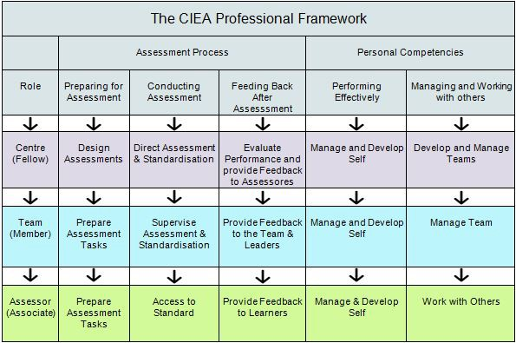

Invoice Details
Please complete details of your organisation and finance department or your own personal details if you are self-funding your course.
Customer's full legal name
NB: If a Limited Company please also provide official letterhead of company showing company name, number and registered office address
Customer's full postal address |  | FAO : Accounts Payable
Address line 1
Address line 2
Address line 3
City
County
Post Code
Country
Accounts Payable telephone number
Accounts Payable e-mail address
VAT Reg No. (EU customers only)
UK, EU or overseas sales?
Purchase Order Number
Please add a Purchase Order number if your organisation requires this to be quoted on the invoice. The purchase order should be emailed to administratorciea@herts.ac.uk
If customer is a company is it an SME?
 | CHECK LIST
 | 1) Completed Personal Details for all Programmes |  | Y / N
 | 2) Completed Work Experience, for the Certificate or CEA |  | Y / N
 | 3) Attached current CV, for Certificate or CEA |  | Y / N
 | 4) Attached Exemption form for Certificate, if required |  | Y / N
 | 5) Completed Assessment Experience for all Programmes |  | Y / N
 | 6) Completed Invoicing Details, for all Programmes |  | Y / N
On completion of this form please email to:
administratorciea@herts.ac.uk

FOR OFFICE USE ONLY

Application Form Received | Enter date
Date Approved | Enter date

