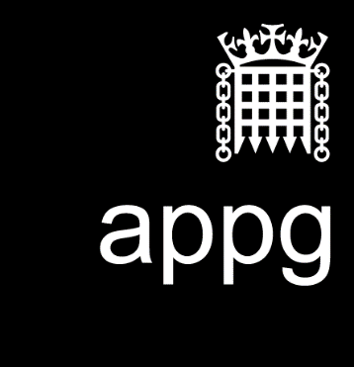
All Party Parliamentary Group for the Teaching Profession

SIG Enquiry into Initial Teacher Education
Responses by 2nd April 2021

Introduction
This call for evidence invites views on the provision of ITE in England, with particular regard to its strengths and areas for further development.

Written evidence, of no more than 2,000 words in total (plus annexes), should be submitted to: kate@waterman.education by 2nd April 2021.

An oral evidence session will be held, by invitation, later in April. A formal report will be published before the end of May 2021. Written evidence may be published as an Annex to the report, unless requested otherwise by the authors.

The review is being conducted under the auspices of the All-Party Parliamentary Group for the Teaching Profession and is being chaired by Lord Knight of Weymouth.

Background
OfSTED currently rate all ITE in England as being either good or outstanding and has reached similar conclusions under a succession of different inspection frameworks. However, the context has changed since the last inspections were carried out, notably in regards to: the impact of Covid 19; policy changes, including the introduction of the Core Content Framework (CCF), the Early Career Framework (ECF) and the establishment of 87 new teaching school hubs.

The Department for Education announced its intention to review the ‘shape of the ITE market’ in its January 2019 Teacher Recruitment and Retention Strategy. The review did not, however, begin in earnest until the autumn of 2020 when an Expert Advisory Group was established. A formal statement about the review was made on 2 January 2021 alongside an announcement about the establishment of a new Institute of Teaching (IOT). Although technically separate from the market review, IOT documentation refers to it as being part of an ‘ambitious’ reform of ITE.

The initial training of teachers is core to the work of the APPG for the Teaching Profession. We are therefore carrying out this urgent review to inform the debate around any proposed changes to Initial Teacher Education.

You do not have to answer every question but there is an overall limit of 2000 words.
The responses to each question will be collated by a different member of the SIG.
To help the administration, please put you name in the header.

1. Is there a quality problem with NQTs?

2. Are there economies of scale in ITE provision?

3. How could schools be better incentivised to be more involved in ITE?

4. How can ITE be improved?

5. If it is decided to implement significant change to the provision of ITE, what would be the best timing for any change?

