Article Title in Title Case: Capitalise each Major Word

First Name Surname, Institutional Affiliation, Country

Abstract
200 words explaining the research context, research question, methodology, findings or conclusions and significance of the article. Do not use footnotes or endnotes here. References can be made as inline author date references (Surname Year: pp as needed in the event of direct quotation from paginated material). The abstract should be isolated on the first page with the main text following a page break on the next page.

Opening Subheading as Needed
Text. No indentation for paragraphs which follow a heading or subheading.

Indent quotations of more than 45 words (Surname Year: pp for paginated material, n.p. for material without pages or page numbers)

Text indented by one tab stop to indicate a new paragraph. Text indented by one tab stop to indicate a new paragraph. Text indented by one tab stop to indicate a new paragraph.

Further Subheadings as Needed
Subheading should describe the content of the section they precede. Text. No indentation for paragraphs which follow a heading or subheading. Text. No indentation for paragraphs which follow a heading or subheading. Text. No indentation for paragraphs which follow a heading or subheading.
Further paragraphs not preceded by a heading or subheading should have their text indented by one tab stop to indicate a new paragraph. Text indented by one tab stop to indicate a new paragraph. Text indented by one tab stop to indicate a new paragraph.
Text indented by one tab stop to indicate a new paragraph. Text indented by one tab stop to indicate a new paragraph. Text indented by one tab stop to indicate a new paragraph.

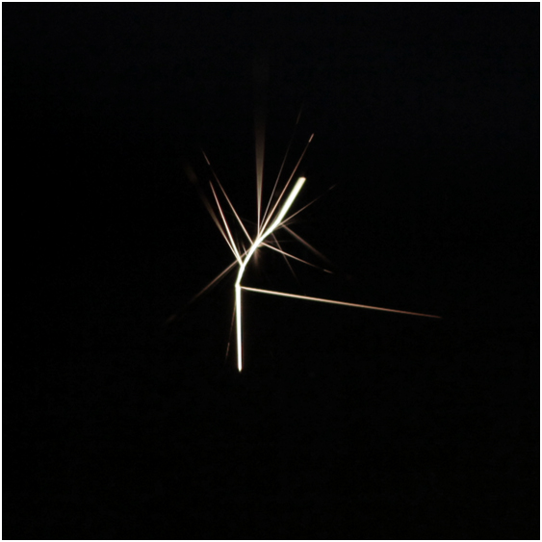
Figure 1 – Title, Description. Copyright permission acknowledgement.

Further Subheadings as Needed
Subheading should describe the content of the section they precede. Text. No indentation for paragraphs which follow a heading or subheading. Text. No indentation for paragraphs which follow a heading or subheading. Text. No indentation for paragraphs which follow a heading or subheading.
Further paragraphs not preceded by a heading or subheading should have their text indented by one tab stop to indicate a new paragraph. Text indented by one tab stop to indicate a new paragraph. Text indented by one tab stop to indicate a new paragraph.
Text indented by one tab stop to indicate a new paragraph. Text indented by one tab stop to indicate a new paragraph. Text indented by one tab stop to indicate a new paragraph.

References

See the Chicago Manual of Style. A CMOS Quick Guide is published online at: http://www.chicagomanualofstyle.org/tools_citationguide/citation-guide-2.html and the following examples are taken from this source.
Arrange entries in the list of references alphabetically by author surname and indent the second and subsequent lines of each entry in the list of references as shown here. The text should be 1.5 spaced as per the main text and should have 10pt spacing after, with no hard returns between entries.
Grazer, Brian, and Charles Fishman. 2015. A Curious Mind: The Secret to a Bigger Life. New York: Simon & Schuster.
Smith, Zadie. 2016. Swing Time. New York: Penguin Press.
Thoreau, Henry David. 2016. “Walking.” In The Making of the American Essay, edited by John D’Agata, 167–95. Minneapolis: Graywolf Press.
D’Agata, John, ed. 2016. The Making of the American Essay. Minneapolis: Graywolf Press.
Lahiri, Jhumpa. 2016. In Other Words. Translated by Ann Goldstein. New York: Alfred A. Knopf.
Austen, Jane. 2007. Pride and Prejudice. New York: Penguin Classics. Kindle.
Borel, Brooke. 2016. The Chicago Guide to Fact-Checking. Chicago: University of Chicago Press. ProQuest Ebrary.
Kurland, Philip B., and Ralph Lerner, eds. 1987. The Founders’ Constitution. Chicago: University of Chicago Press. http://press-pubs.uchicago.edu/founders/.
Melville, Herman. 1851. Moby-Dick; or, The Whale. New York: Harper & Brothers. http://mel.hofstra.edu/moby-dick-the-whale-proofs.html.
Keng, Shao-Hsun, Chun-Hung Lin, and Peter F. Orazem. 2017. “Expanding College Access in Taiwan, 1978–2014: Effects on Graduate Quality and Income Inequality.” Journal of Human Capital 11, no. 1 (Spring): 1–34. https://doi.org/10.1086/690235.
LaSalle, Peter. 2017. “Conundrum: A Story about Reading.” New England Review 38 (1): 95–109. Project MUSE.
Satterfield, Susan. 2016. “Livy and the Pax Deum.” Classical Philology 111, no. 2 (April): 165–76.
Bay, Rachael A., Noah Rose, Rowan Barrett, Louis Bernatchez, Cameron K. Ghalambor, Jesse R. Lasky, Rachel B. Brem, Stephen R. Palumbi, and Peter Ralph. 2017. “Predicting Responses to Contemporary Environmental Change Using Evolutionary Response Architectures.” American Naturalist189, no. 5 (May): 463–73. https://doi.org/10.1086/691233.
Manjoo, Farhad. 2017. “Snap Makes a Bet on the Cultural Supremacy of the Camera.” New York Times, March 8, 2017. https://www.nytimes.com/2017/03/08/technology/snap-makes-a-bet-on-the-cultural-supremacy-of-the-camera.html.
Mead, Rebecca. 2017. “The Prophet of Dystopia.” New Yorker, April 17, 2017.
Pai, Tanya. 2017. “The Squishy, Sugary History of Peeps.” Vox, April 11, 2017. http://www.vox.com/culture/2017/4/11/15209084/peeps-easter.
Pegoraro, Rob. 2007. “Apple’s iPhone Is Sleek, Smart and Simple.” Washington Post, July 5, 2007. LexisNexis Academic.
Kakutani, Michiko. 2016. “Friendship Takes a Path That Diverges.” Review of Swing Time, by Zadie Smith. New York Times, November 7, 2016.
Stamper, Kory. 2017. “From ‘F-Bomb’ to ‘Photobomb,’ How the Dictionary Keeps Up with English.” Interview by Terry Gross. Fresh Air, NPR, April 19, 2017. Audio, 35:25. http://www.npr.org/2017/04/19/524618639/from-f-bomb-to-photobomb-how-the-dictionary-keeps-up-with-english.
Bouman, Katie. 2016. “How to Take a Picture of a Black Hole.” Filmed November 2016 at TEDxBeaconStreet, Brookline, MA. Video, 12:51. https://www.ted.com/talks/katie_bouman_what_does_a_black_hole_look_like.
Google. 2017. “Privacy Policy.” Privacy & Terms. Last modified April 17, 2017. https://www.google.com/policies/privacy/.
Yale University. n.d. “About Yale: Yale Facts.” Accessed May 1, 2017. https://www.yale.edu/about-yale/yale-facts.
Chicago Manual of Style. “Is the world ready for singular they? We thought so back in 1993.” Facebook, April 17, 2015. https://www.facebook.com/ChicagoManual/posts/10152906193679151.
Souza, Pete (@petesouza). 2016. “President Obama bids farewell to President Xi of China at the conclusion of the Nuclear Security Summit.” Instagram photo, April 1, 2016. https://www.instagram.com/p/BDrmfXTtNCt/.

Contact
Title Firstname Surname
Job Title as relevant
Institution
Institutional address
Country
Email address - hyperlinked
Website – hyperlinked.

