NOTIFICATION OF A FORMAL COMPLAINT UNDER THE PROVISIONS OF THE STUDENT AND APPLICANT COMPLAINTS PROCEDURE (UPR SA16)

NOTES FOR GUIDANCE AND COMPLAINT FORM – APPLICANTS

- The University of Hertfordshire aims to ensure that applicants are assessed in their application process fairly and reasonably but, as with any large and complex organisation, it is always possible that unsatisfactory circumstances occur. If that should happen, the University has a two-stage process, Informal (Preliminary) and Formal, to deal with complaints that may arise. Complainants must complete each stage before they can progress to the next. The complete policy is detailed in version 01.0, UPR SA16, ‘Student and Applicant Complaints’, but these notes provide a summary. This document is published on-line at the following location and you are advised to read in full:

SA16 V1 Student and Applicant Complaints

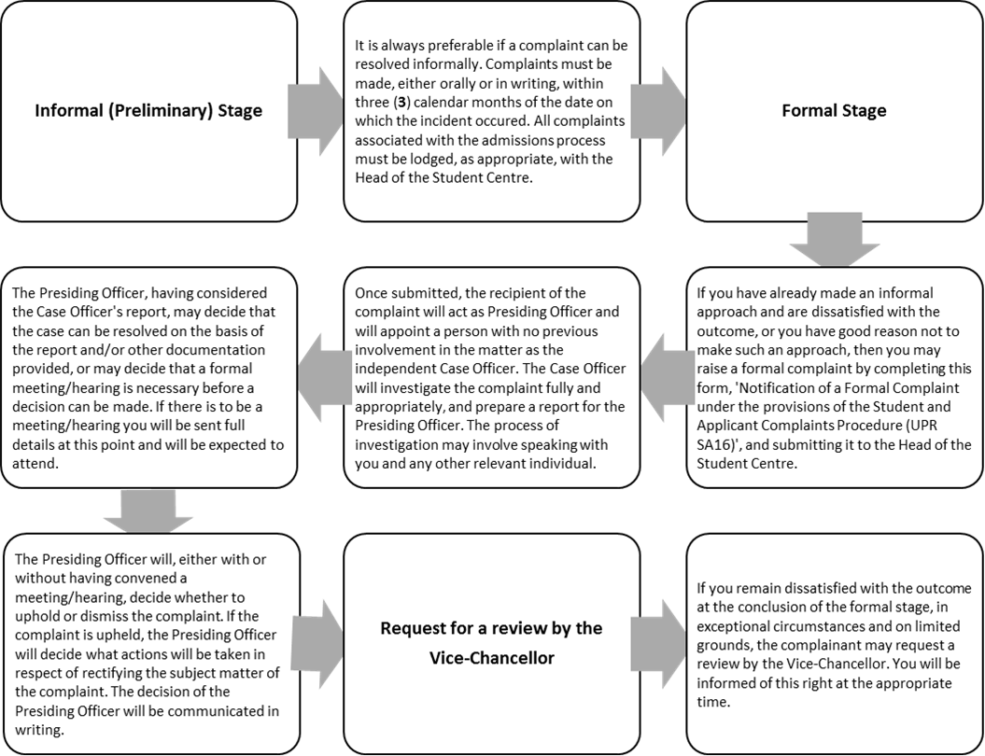
- To ensure that when submitting a Formal Complaint, all necessary information is provided so that the University is able to deal with the matter efficiently, applicants are expected to use this form. With regard to the requirement to submit requests using the appropriate form, the University will make reasonable adjustments for disabled applicants.

- The University expects that at the time of making a Formal Complaint, an applicant will bring forward all relevant evidence that is available at the time at which the formal complaint is lodged.

Cont’d/

- It is expected that during the course of any complaints all parties will act courteously, fairly and reasonably towards each other and to comply with the requirements of the procedures by completing complaints’ documentation, adhering to any deadlines, responding appropriately to any requests for information or attendance at meetings/hearings and undertaking any reasonable action require to reach a satisfactory remedy. Remember that mediation is available by agreement between both/all parties.

- All complainants will be treated equally, regardless of their status or seniority, and will not be treated adversely as a result of their having made a complaint.

April 2019

NOTIFICATION OF A FORMAL COMPLAINT UNDER THE PROVISIONS OF THE STUDENT AND APPLICANT COMPLAINTS PROCEDURE (UPR SA16)

COMPLAINT FORM – APPLICANTS

- Applicants are STRONGLY ADVISED to read the attached Notes for Guidance before raising a formal complaint.
- Applicants are also ADVISED to read the full regulation (UPR SA16) before submitting this form.
- Support and guidance can be sought from the Office of the Dean of Students.

Personal Details (please print):

Applicant Name:

UCAS/other Identification Number:

Correspondence Address:

Contact Number:

E-mail Address:

Programme of Study applied to:

Date of initial contact regarding Informal Complaint and who this contact was with:

Outcome of Informal Complaint:

Please give details of your Formal Complaint and the desired outcome. Where you refer to supporting evidence, please number those documents. You may continue on a separate sheet if necessary.

Please list and number any documents that you are providing as supporting evidence:

Signature ………………………………………………………

Date ………………………………………………………
Please submit the completed form to:

Head of the Student Centre
University of Hertfordshire
Hutton Hub
Ground Floor
College Lane
Hatfield
Hertfordshire
AL10 9AB

E-mail: ask@herts.ac.uk

For Office use only

Date Formal Complaint received:

Head of Student Centre (or nominee) decision:

Date of Head of Student Centre (or nominee) decision:

